ST. XAVIER’S COLLEGE

**(Affiliated to Tribhuvan University)**

Maitighar, Kathmandu



**Computer Graphics**

**Lab Assignment #1**

**Submitted by:**

Pankaj Niroula  
013BSCCSIT025

**Submitted to:**

|  |  |
| --- | --- |
| Er. Anil K. Sah  Lecturer Department of Computer Science |  |

Date: 04 August, 2015

**Draw the checkerboard.**

**Source Code:**

|  |
| --- |
| #include <vcl\vcl.h>  #pragma hdrstop  #include "buildassing.h"  //---------------------------------------------------------------------------  #pragma resource "*.dfm"  TForm1 *Form1;  //---------------------------------------------------------------------------  __fastcall TForm1::TForm1(TComponent* Owner)  : TForm(Owner)  {  }  //---------------------------------------------------------------------------  void __fastcall TForm1::Button1Click(TObject *Sender)  {  Form1->Canvas->Pen->Width=3;  Form1->Canvas->Brush->Color=clWhite;  Form1->Canvas->Rectangle(10,10,210,210);  Form1->Canvas->MoveTo(210,10);  Form1->Canvas->LineTo(10,210);  Form1->Canvas->MoveTo(60,10);  Form1->Canvas->LineTo(60,210);  Form1->Canvas->MoveTo(110,10);  Form1->Canvas->LineTo(110,210);  Form1->Canvas->MoveTo(160,10);  Form1->Canvas->LineTo(160,210);  Form1->Canvas->MoveTo(10,60);  Form1->Canvas->LineTo(210,60);  Form1->Canvas->MoveTo(10,110);  Form1->Canvas->LineTo(210,110);  Form1->Canvas->MoveTo(10,160);  Form1->Canvas->LineTo(210,160);  Form1->Canvas->MoveTo(10,210);  Form1->Canvas->LineTo(210,210);  Form1->Canvas->MoveTo(210,10);  Form1->Canvas->LineTo(210,210);  Form1->Canvas->MoveTo(10,10);  Form1->Canvas->LineTo(210,10);  Form1->Canvas->MoveTo(10,10);  Form1->Canvas->LineTo(210,210);  } |

**Output Screeen:**

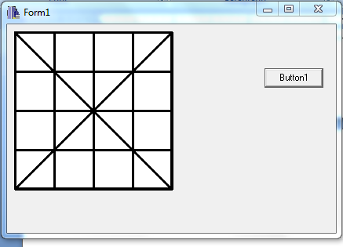

**Conclusion**

Thus, C++ Builder can be used to draw graphic elements like boxes and lines as shown above.